Mixed Pond proposed management

Aim
  - Re-establish the original profile of the pond at the northern end through desilting
- Retain silt at the pond edge thus creating new wetland habitat and reduce vehicle movements to landfill.
- Create 2-4m width of wetland vegetation along 60-90m of bankside.

Bankside management required

- Marginal and emergent plants can be established along the margins only if the shade from bankside vegetation is reduced.
- Coppice 2-3m width of bankside vegetation every 1-3 years to prevent shading. This can be done on rotation.
- Create dead hedge to prevent bankside access and enhance bird nesting opportunities. This would also catch wind-blown leaves.
- Remove ivy from standard trees and old hawthorns.
- Pollard or coppice selected hawthorns to reinvigorate. Many of which have little visible growth due to ivy cover. Many have also fallen or had the tops snapped off due to the reduced wind resistance.
- Maintain open section to the far SE for access and viewing.
- Coppice 3-4 saplings trees along west bank to create potential emergent planting bay.

Similar bankside works were carried out 10 years ago along the east bank but no wetland vegetation was established.

Possible timescale
  - Bankside works to be carried out in-house prior to bird nesting season. January or February. Up to 5 days
  - Desilting works and planted revetments created Mid-end of March 2018 by contractors. C.15 days. Swimming is likely to be restricted or unavailable during this time.
Benefits
  - A reduction in sediment will decrease the potential for re-suspension of material back into the water column decreasing visibility.
  - Sediment stores nutrients which can be released back into the water causing water quality problems such as algal blooms.
- Emergent vegetation will increase the available spawning sites for amphibians and provide habitat for invertebrates. The east bank used to be a major toad spawning site until the bankside vegetation decreased its suitability for toads.
- The vegetation will provide a refuge for zooplankton which are important for pond ecology as consumers of algal growth, thus helping to create clearer pond conditions.
- Improved sight lines for lifeguards.
- Reduced leaf fall into the water.

- Proposed management will not reduce the available swimming area
- Proposed management will retain the majority of the screening provided by the trees/scrub towards the path.

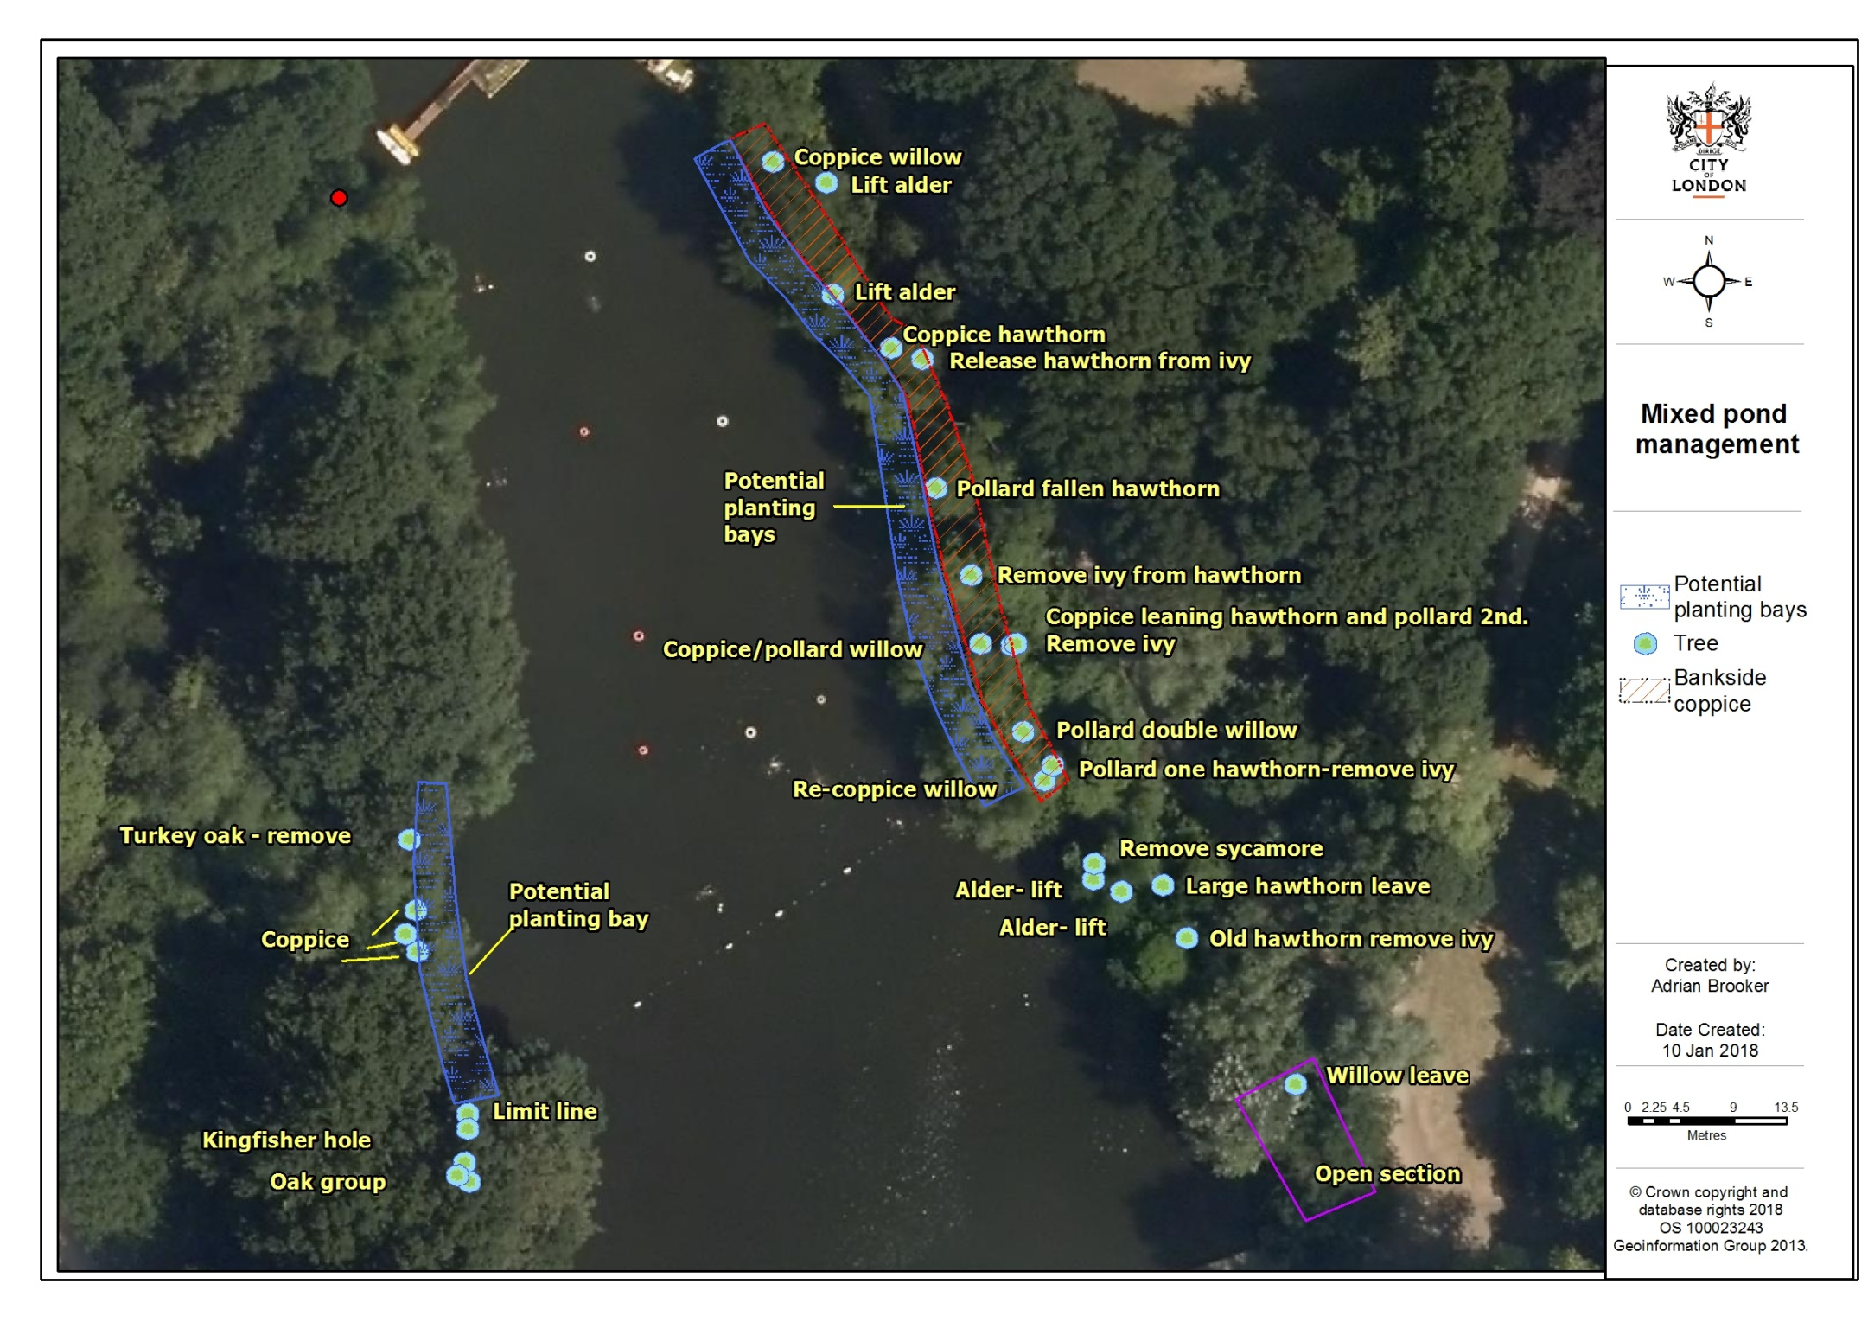
Figure 1: Mixed Pond proposed management

